Infinitive Phrase Subject

✅ What is Infinitive Phrase Subject
# Source: AI Source: Provided by: [Data Path: Persons Table -> ID Column: 1, Name_En Column: Motasem Essam] -> From: [Chatgpt (GPT-4-turbo)] on [8/4/2025]
An infinitive phrase subject is a phrase that begins with an infinitive ("to" + base verb) and includes objects, modifiers, or complements—functioning together as the subject of the sentence.
It answers "what is performing the action?" and acts as a noun.

🔹 Structure:
# Source: AI Source: Provided by: [Data Path: Persons Table -> ID Column: 1, Name_En Column: Motasem Essam] -> From: [Chatgpt (GPT-4-turbo)] on [8/4/2025]
To + base verb + (object/modifiers/complements)

🔹 Key Features:
# Source: AI Source: Provided by: [Data Path: Persons Table -> ID Column: 1, Name_En Column: Motasem Essam] -> From: [Chatgpt (GPT-4-turbo)] on [8/4/2025]
- Functions as a complete subject.
- Can be long or short depending on what follows the infinitive.
- Verb usually stays in the singular form when the infinitive phrase is subject.

🔹 Examples of Infinitive Phrase Subjects:
# Source: AI Source: Provided by: [Data Path: Persons Table -> ID Column: 1, Name_En Column: Motasem Essam] -> From: [Chatgpt (GPT-4-turbo)] on [8/4/2025]
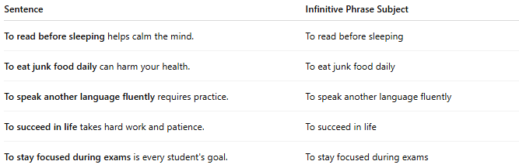
Sentence | Infinitive Phrase Subject
To read before sleeping helps calm the mind. | To read before sleeping
To eat junk food daily can harm your health. | To eat junk food daily
To speak another language fluently requires practice. | To speak another language fluently
To succeed in life takes hard work and patience. | To succeed in life
To stay focused during exams is every student's goal. | To stay focused during exams

🔍 Difference:
# Source: AI Source: Provided by: [Data Path: Persons Table -> ID Column: 1, Name_En Column: Motasem Essam] -> From: [Chatgpt (GPT-4-turbo)] on [8/4/2025]
- Infinitive Subject: To sleep is important.
- Infinitive Phrase Subject: To sleep early and regularly is important.

